The Busy Mom’s Guide to Fitness Success


Essential Tips & Strategies to Help You Stay Fit & Healthy Despite Your Busy Schedule

If you are a mom and wife like me, I am willing to bet that your life is FULL to overflowing. This guide was designed to help you to see that no matter how busy life can get (and they can get downright hectic), there are some creative ways that you CAN get and stay fit and healthy without having to spend major hours in the gym in order to accomplish this goal.

Most busy moms automatically think that getting and staying fit is an overwhelming task that requires hours of time in the gym, and constantly wonder if their time would be better spent doing other “more important” tasks such as running errands or cleaning the house. I want to tell you there is no more important task that you will ever have than taking care of YOU.

When you feel good about yourself, and are free from personal guilt that comes from neglecting your personal goals, you are much more able to care for your family. Trust me, when mom is happy…everyone is happy (I am sure you’ve heard that one before!)
What I’ve done in thus guide is to show you how you can accomplish all that you want through some simple time-saving fitness activities you can incorporate into your day to help you to get and stay in shape while also taking care of your family and your business. Are you ready to get going? Let’s dive right in!

Simplify Your Fitness
When busy times come, rather than ignoring exercise altogether, what you can do is try to think of exercise as you would any other major task in your office. Tackle it by breaking it up into small components so that it will not seem so overwhelming.

Instead of seeing yourself spending two hours at the gym or yoga studio doing countless mundane exercises that hurt and that you don’t even like…see yourself being just as productive and accomplishing your fitness goals in just a fraction of the time while enjoying yourself.

Do you have just 20 minutes…great, think about doing activities in those 20 minutes that will provide the same results as your two-hour routine would accomplish. The truth is that it’s possible to do more in less time…if you have the right guidance. Below are some suggestions for how to structure your exercise plan to allow you to accomplish more with less time:

Suggestion #1:
20 minutes four days a week, i.e.: 15 minutes cardio, 5 minutes resistance training (body weight exercises such as squats and lunges)
- Schedule: Monday, Wednesday, Friday, Sunday
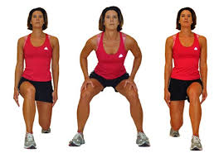
Suggestion #2
20 minutes three days a week
- Monday: 20 minutes cardio
- Wednesday: 10 minutes of resistance training (upper body & lower body) + 10 minutes of cardio
- Friday: 5 minutes cardio + 15 minutes of resistance training (lower body only)


Suggestion #3
20 minutes 5 days a week.
[Monday, Tuesday, Wednesday, Friday & Saturday]
- Week 1: all cardio
- Week 2: Resistance training body weight exercises
- Week 3: Cardio on Monday, Wednesday, & Friday
Resistance training on Tuesday & Thursday
- Week 4: Repeat Week 3 Schedule
Repeat the entire cycle when you get to month 2.

Frequency and Intensity
Ideally, one should gradually increase the frequency or intensity, or both, however, if you’re busy, and definitely can’t spare more than 20-30 minutes at a time, then your main priority should be to increase your intensity. This means if your cardio involves the treadmill, take the speed or incline up to the next level.
For your weight training, if you started with 20 squats and 20 lunges, then look to increase the number of each exercise each week you participate in those activities. If you started with 20 squats or lunges in week 1, then work to increase the number by 2 – 5 repetitions by week 2.
Be realistic with your goals, especially when you’re just starting. Increasing your frequency and intensity too soon can overwhelm you, and increase your chances of injury, thus putting a screeching halt to your fitness routine. This is something we want to avoid at all costs.

Variety is the Spice of Life
Another way to integrate exercise into your busy schedule is to vary your weekly routine. Variety in your routine will keep you motivated to maintain your workout program. Without variety, boredom will inevitably set in and cause you to discontinue your fitness efforts. Variety also enables you to you to be creative and incorporate as many different types of exercises as possible. This way, you’re able to try many exercises and then adopt those that you enjoy and are most comfortable with.

Walk before you Run!
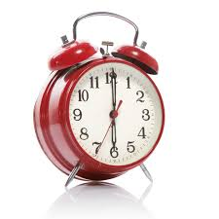
If you are an absolute beginner, a full-blown workout that incorporates cardio, resistance training, and flexibility may scare or discourage you. The idea is to start with small steps. Do ONLY what you are able to do given your current fitness level and then gradually increase the intensity of your activities as you are physically able to accommodate higher levels of exercise.

Time Management
If your schedule requires you to get up in the morning to start your day at 7 am, and then keeps you running all day until bedtime, it may be best if you consider a workout schedule that accommodates exercise either before or after your day would normally begin.

I would recommend, perhaps, a waking time of 6 am (1 hour earlier) so that you can complete your 20-minute routine, shower, and have breakfast before your normal 7 am waking time. It may not seem like you’re doing as much as you might have otherwise envisioned, however, you’re accomplishing something very significant in that you’re committing to exercise 20 minutes 3 days a week, and setting time aside that otherwise was devoted to something else. You’re creating a habit that will serve you very well and set the stage for much greater things.
Workplace Fitness
If you are someone who goes to an office each day, there are many good options for you to increase your daily activity levels and improve your fitness. In the fitness industry, experts recommend that office workers who sit long periods of time get up from the chair and take a walk throughout the building (or outside) while making sure to include walking up and down the stairs to help with calorie burning.


When you feel the need to take a break, consider running errands for your colleagues and supervisors. This will force you to get up from your seat and be more active throughout your workday. You may also want to consider purchasing and bringing some dumbbells, mats and elastic bands, and incorporating some easy resistance training activities while sitting at your desk or standing in your office.

EASY Family Exercises
On the weekends when you and your family are out and about…shopping, at the park, or at their sporting events…try to integrate exercise into these activities. Consider enrolling in adults activities at the same time that your kids are participating in theirs, or simply take a walk outside the recreational center while waiting for them.

Chores Burn More Calories!
Who says you can’t burn calories while doing housework or gardening? One great strategy to use if you work from your home is to take periodic breaks throughout the day to mow your lawn, trim your bushes, tidy up the house, or clean the kitchen and bathroom floors.

Walk Instead of Drive!
Another great strategy is to park your car far away from buildings that you travel to throughout the day such as the Super Market, Mall, Doctor’s office, Dentist, or even the Post Office.

Are You a Busy Traveler?
If you are a frequent flyer, and find that you’re away from home so often that it’s difficult for you to establish a consistent fitness schedule, it’s totally understandable. It can be a major challenge, for sure! Some of your common struggles are dealing with the stress of travel, the fatigue of sitting on cramped airplanes, and then having to deal with Uber rides to and from the airport…not to mention the struggles of dealing with hotel life. The following are some tips that may be helpful to get you on track for success while on the road.

Walk when on the Road

When traveling, have a pair of good sneakers designed for walking so that you more easily get into the mode of walking for fitness when you’re in transit (to and from the airport). Having the right footwear will encourage you to use the stairs rather than taking the escalator.

Airplane Fitness
Once you get situated on the airplane, begin thinking about when you’re going to take your “fitness breaks” while in flight. This may be as simple as scheduling a 5 minute walk around the plane and then a quick stretch in the back of the plane. If the flight is longer, just be sure to schedule a fitness break at least once an hour to maintain proper circulation and to ensure that you do not grow stiff throughout the duration of the flight.
Hotel Fitness
When traveling on vacation or while away on business, it would benefit you to make it a priority to either get up earlier in the morning or after the kids are in bed, head over to the gym and take a 10-minute walk or do 10 minutes on the rowing machine. At either part of your day, this activity will do wonders for your outlook on your day, improve your circulation, and help keep you in the “fitness mindset” for the duration of your trip. It will also help you make good decisions with regard to your food choices.

If you want to add a little additional to your fitness for each day while away from home, feel free to add a 10-minute fitness session (at the opposite end of the day from your cardio session) that includes resistance-training activities. This strategy will allow you to complete both your cardio and resistance training activity for the day.

What To Do When There Is No Gym!
When the hotel gym is too crowded, closed for maintenance, or there simply isn’t one available for your use, there are still things you can do to improve your fitness. The best option includes walking outside, assuming there is good weather, or simply working out in your hotel room.

Hotel Room Exercises You Can Do:
- Turn some music on and jog in place or do jumping jacks – to the beat
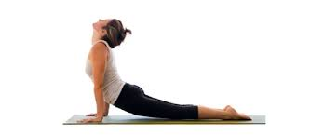
- Conduct floor exercises for total body development
  - Floor exercise 1: the Cobra (or back extension). Lying on your stomach as though getting ready for push-ups, keep your hands on your side with palms facing down and fingers pointed forward. With your hands, push to lift your torso off the floor (ensure you are lifting your head, shoulders and chest off the floor only). Keep pelvis on the floor and your head looking straight ahead. Hold for 10-20 seconds and then release. Repeat 2 times. You should feel your spine lengthen.

  - Floor exercise 2: Crunch (for lower abdominals).
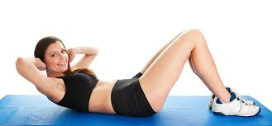
The lower abdominals are typically the weakest muscles in your torso because they are not worked consistently on a daily basis, and are also the first to sag following childbirth and following the menopausal years.

A Good Stretch for the Lower Abdominals:
- Lying flat on your back with your knees bent, cross your arms over your chest. Squeeze your buttocks, tighten your abdomen and push your lower back into the floor. Hold for 10-20 seconds, breathing normally. Relax, and then release. Repeat as often as you can, without overexertion.
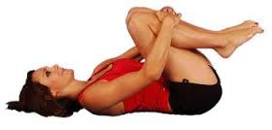

A Good Stretch for the Legs & Lower Back:
- Floor exercise 3: Hurdler’s Stretch. Bend the knee towards the front, and then tuck your lower leg in toward the opposite thigh. Stretch gently toward the straight leg. Do not bounce. Hold the stretch for 15-30 seconds and then release.
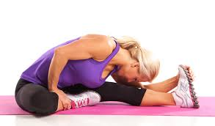
For more stretches and fitness exercises you can do while on-the-go, feel free to reach out to me and I’ll send you some additional fitness resources that will really help you accomplish your goals in less time.

Exercise Equipment “To Go”…OR Not!
Below is a list of fitness equipment you should consider which allow you to exercise effectively both at home and when travelling:
- Resistance bands (light & moderate bands)
- Dumbells (A pair of…2lbs, 3lbs, 5lbs, 8lbs, & 10lbs)
- A mesh jump rope
- A stability ball
- 3-5 types of exercise DVD’s that will address different aspect of fitness.
  - High Intensity Fitness
  - Low Intensity Fitness
  - Pilates
  - Yoga
  - Body Weight &/or Moderate Resistance Training
- Yoga mat
- Pandora or other Phone App that allows you to access your favorite music easily

Using a Wearable Technology Device
These devices will help you to easily manage your health, track your steps, and generally keep tabs on your efforts to maintain good fitness levels. These devices are very popular today, and could be just what you need to keep yourself on track throughout the year. Some popular brands include:
- Helo LX
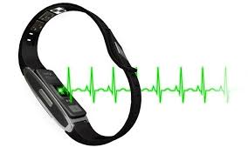
- Fitbit
- Apple Watch
- Garmin
- Huawei
- Samsung
The list definitely goes on…but the main thing is that it may be good consider one of these options if you’re into technology, and if you need a bit of help managing your health profile. Busy moms can really benefit from these types of products.

Items to Always Have On Hand...
Always have the following items with you as you travel:
- Comfortable walking footwear
- Padlock
- Gym Bag

Eating Fit!
Let’s not forget that the quality of your daily nutrition will determine the type of results you will achieve with your fitness efforts! If you need suggestions for how you can eat well whether at home or on the go, reach out to us for any help you need with optimizing your nutrition and maximizing your results.
Remember, we’re here for you! Feel free to reach out to us with any questions or if you need any help on your journey to a better body.

